WALK WITH US

JULY 2017 – JUNE 2018
ANNUAL REPORT
To be read at meeting 25th May 2019

WALK WITH US

Our mission
Our mission is to help those less fortunate in the Gold Cost Community by helping them with food, clothes, toiletries and helping them cope with the challenge’s life throws them. We are offering the hand of friendship to these people who need a break in life.
Our motto is ‘Be a good human’ and this is what we are all trying to be.

Our vision
We want to just keeping doing what we are.

Our vision is to finally open up a hub for our homeless and disadvantaged friends. This would be a place for them to come along and be able to cook up a meal or take from fridge our prepared meals. Have a shower and do their washing etc. We wish to set up computers so they can come in and go online and apply for jobs or look for housing or connect with Centrelink etc.
This would be a place for them to get out of the weather and relax and get some company.
This hub would be manned by volunteers from 9am – 5pm.

Our History

Walk With Us started back in 2015. 3 Young people wanting to save the world. Well some people on the Gold Coast anyway.

We started by holding an annual Christmas Lunch for between 200-250 people on Christmas Eve. We have held this for the past 4 years at Albert Waterways Community Centre at Broadbeach Waters.
The guests are served up a 3 course meal (which is catered for by outside caterers)
Santa comes along and all guests (young and old) receive a gift
We have live entertainment from local singing schools, local bands and local dance schools. Everyone gets a gift as well as their gift a bag full of toiletries etc. We have a visiting hairdresser, Orange Sky for them to do their laundry
But most importantly our guests have some fun, love and laughter in their lives at a time where you should be around loved ones

Then we started having a dinner every Monday night of the week (rain hail or shine). This was originally in the park but we have so many now we hold it in the GCCC community hall in Burleigh. This is a great night where our friends get a 2 course hot meal, groceries, toiletries and clothes. It is a fun night as we are all like a family now with our volunteers getting involved in conversations with our friends. We celebrate birthdays etc and it is a really fun night. Our volunteers provide the food each week and do an amazing job

.

SECTION 1 | AN OVERVIEW OF WALK WITH US

ABOUT US

We are a friendly group of passionate and proactive people who share a common goal to work amongst the Gold Coast community, supporting the homeless, disadvantaged, youth, lonely, domestic violence and sufferers of mental health.

We are a mixed bunch who have come from a wide range of backgrounds, each with our own story to tell and genuine motivation to help others. At the time of our launch in 2015 we all had previous experience in working amongst the community in varied roles. We understand how quickly and unexpectedly lives can change and how easy it is to fall on tough ti

OUR PEOPLE

Patron

Board members/Founding Members
Name | Position | Dates acted  (if not for whole year)
Nikki Luke | President/Founding member
Jade Kilshaw | Founding member
Matthew Mason | Founding member

Volunteers
Name | Position | Dates acted  (if not for whole year)
Savili Sega | Committee
Sandra Sheppard | Committee
Robyn Luke | Treasurer

OUR SUPPORTERS

Loveday’s Quality Meats

Print IQ

ICON Training Academy

Mudgeeraba Redbacks RLFC

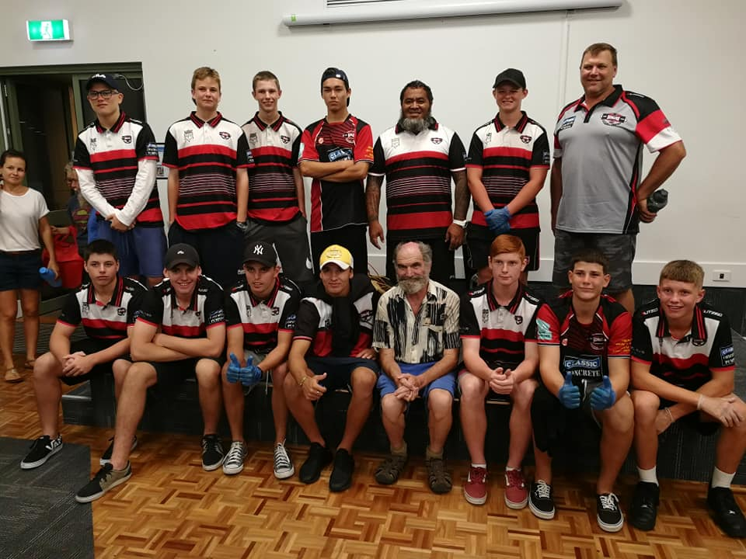

SECTION 2 | GOVERNANCE

STRUCTURE & MANAGEMENT
WALK WITH US is registered with the Australian Charities and Not-for-profits Commission (ACNC).

OUR OBJECTIVES AND ACTIVITIES
Our objective for the next 12 months is to continue doing what we have been doing. Our numbers grow each week so we just need to keep encouraging our friends to attend our dinners.
Christmas luncheon will continue as well and this is another day we enjoy organising.

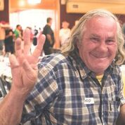
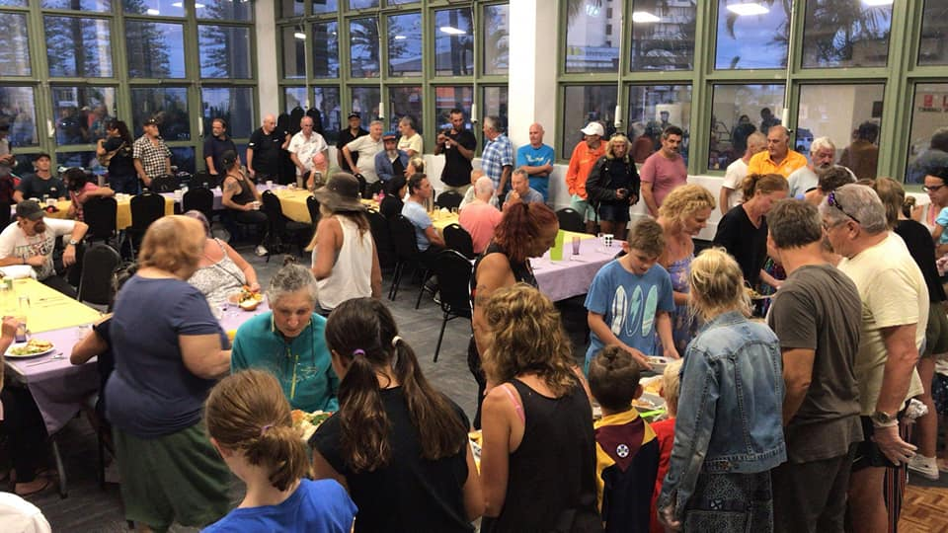
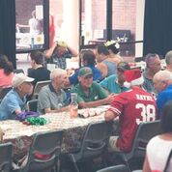

FINANCIAL STATEMENTS

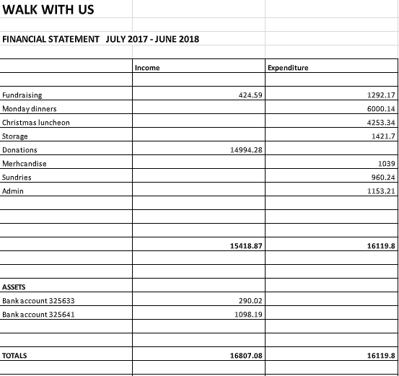

CONTACT US

PO Box 2454 Burleigh BC 4220
0413086646
www:walkwithusgc.com.au
info@walkwithusgc.com.au
www.facebook.com/walkwithusgc/

